**IMPLEMENTING CRM FOR RESULT TRACKING OF A CANDIDATE WITH INTERNAL MARKS**

**1] INTRODUCTION:**

**OVERVIEW:**

**The improved features of CRM software have increased both its complexity and necessity. Nearly half a CRM implementation campaigns suffer from improper preparation and misaligned objectives among internal stakeholders. A properly conceived CRM implementation strategy covers the breakdown of its goals, research, strategy, development and future. This article is for small business owners who want to make sure they are taking the rights steps when implementing a new CRM system.**

**PURPOSE:**

**It is save a lot of time. The purpose of the purpose of the project is to manage the school student’s result tracking process in the easy way. Students do not need to check the notice board and everyone will stay updated this is the main purpose of this project. Can I work easily. Increase candidate quality.**

**2] PROBLEM DEFINITION & DESIGN THINKING:**

**EMPATHY MAP:**

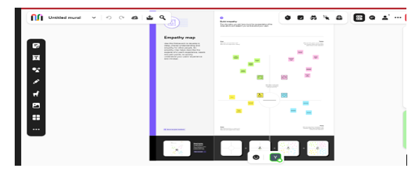

**BRAINSTORMING MAP:**

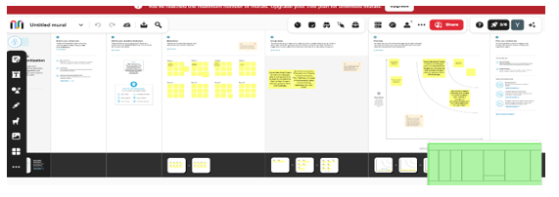

**ACTIVITY & SCREENSHOT:**

**Milestone 1:**

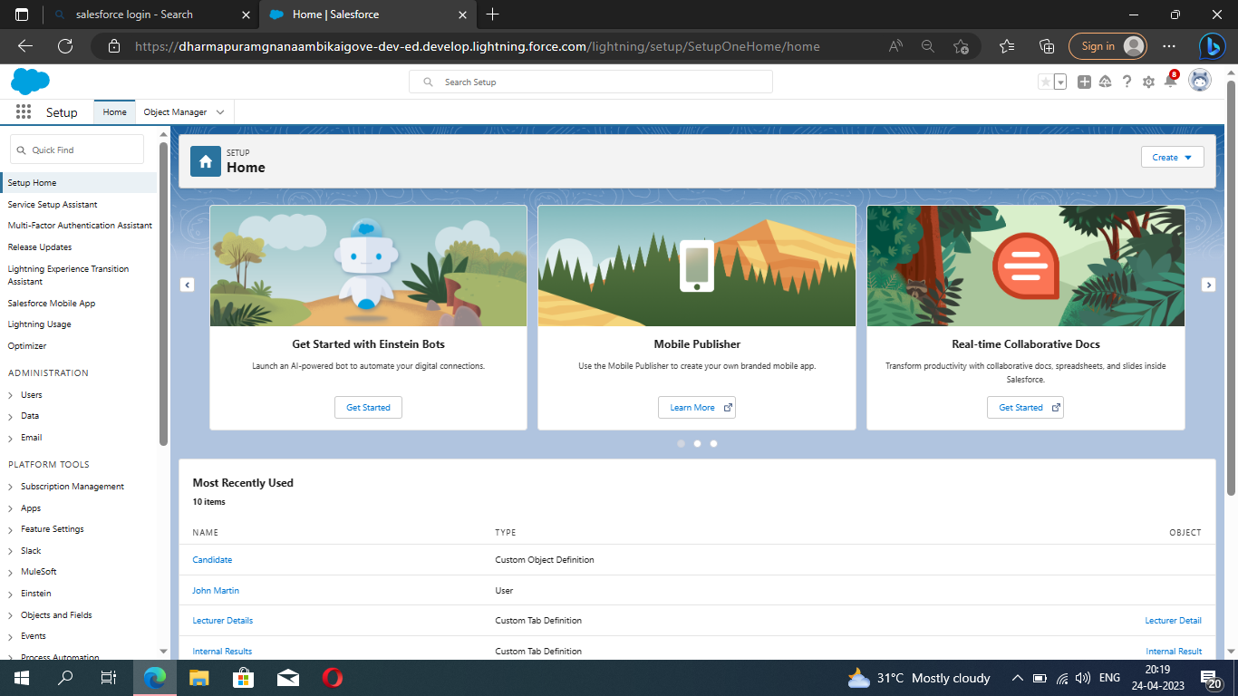

**Milestone 2:**

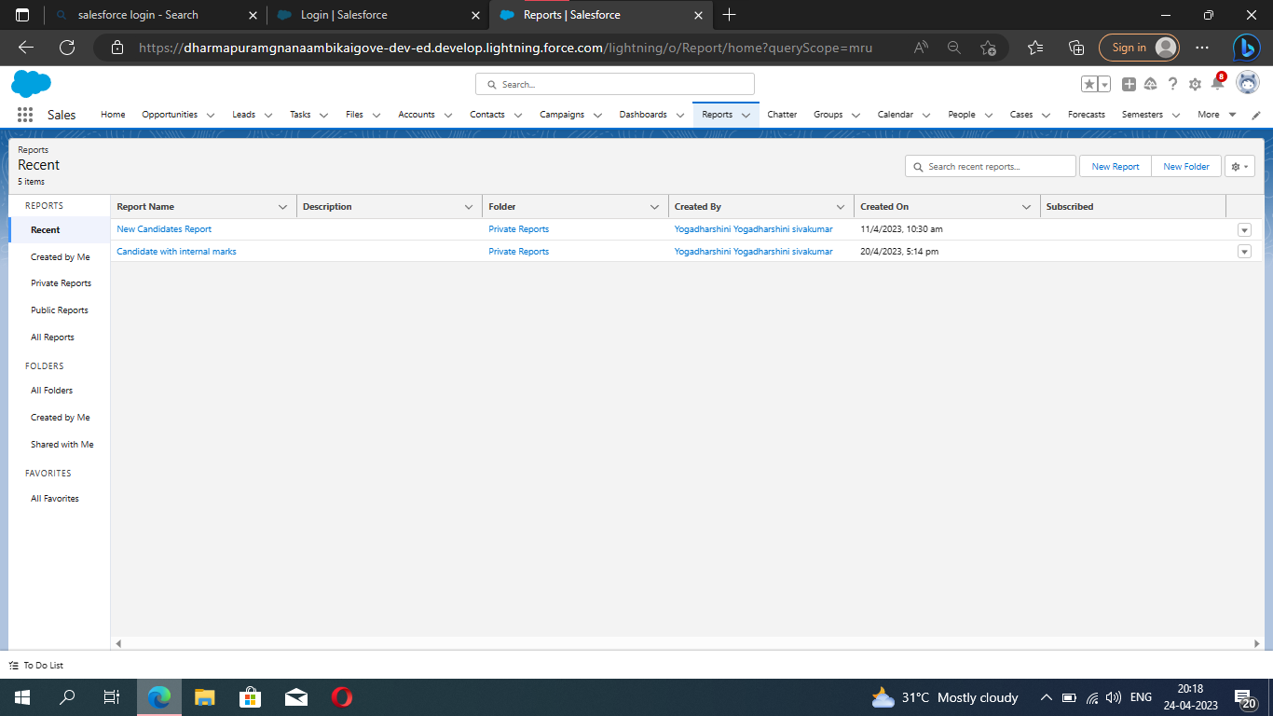

**Milestone 3:**

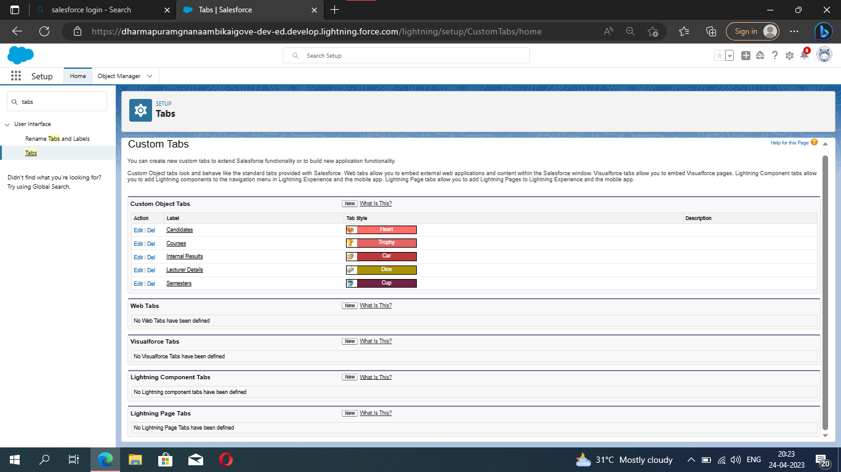

**Milestone 4:**

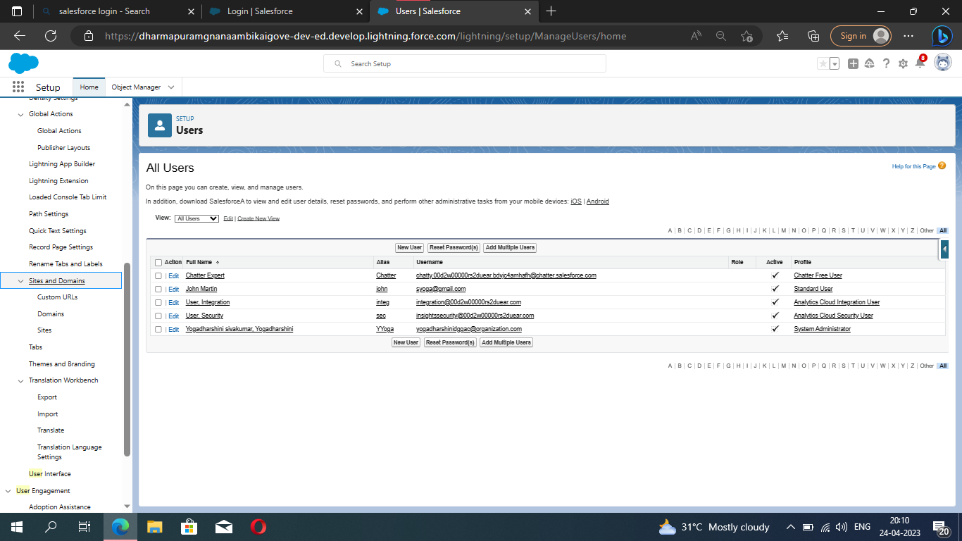

**Milestone 5:**

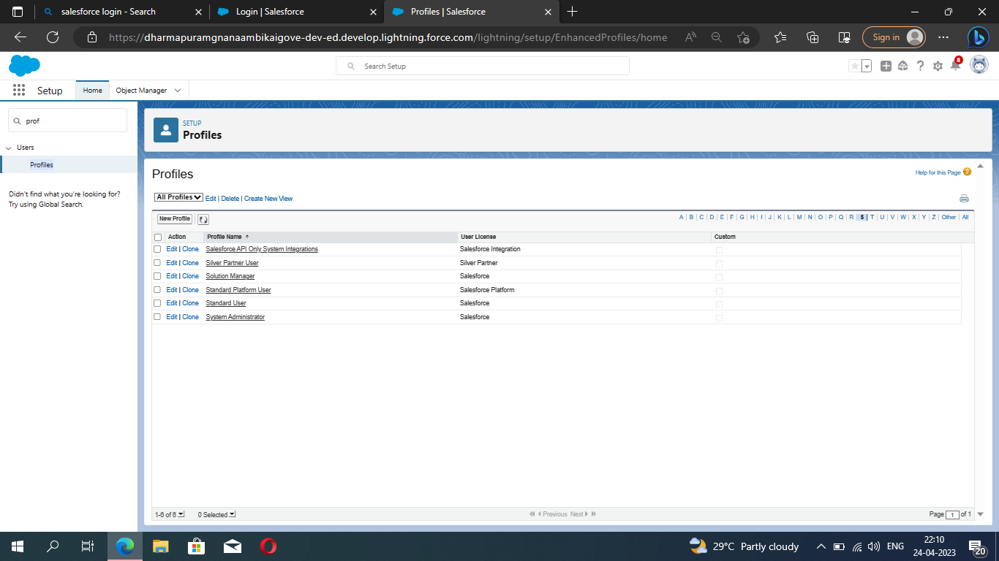

**4] TRAILHEAD PROFILE PUBLIC URL:**

**Team lead -** [**https://trailblazer.me/id/ydharshini1**](https://trailblazer.me/id/ydharshini1)

**Team Member 1 –** [**https://trailblazer.me/id/aaarthi13**](https://trailblazer.me/id/aaarthi13)

**Team Member 2 –** [**https://trailblazer.me/id/aakila5**](https://trailblazer.me/id/aakila5)

**Team Member 3 –** [**https://trailblazer.me/id/ddevigasangar**](https://trailblazer.me/id/ddevigasangar)

**5] ADVANTAGES & DISADVANTAGES:**

**ADVANTAGES:**

* **It allows for the consolidation of customer data and the basis for deep insights.**
* **It speeds up the sales conversion process.**
* **It increases staff productivity, lowering time-cost.**
* **It allows geographically dispersed team to collaborate effectively.**
* **Improves customer experience by allowing personalization and improved query resolution.**

**DISADVANTAGES:**

* **Customer experience may worsen due to staff over-reliance on the system.**
* **Security and data protection issues with centralized data.**
* **The excess initial time and productivity cost at the implementation.**
* **Requires a process-driven sales organization.**
* **CRM may not suit all business.**

**6] APPLICATION:**

* **I want something reliable.**
* **Target marketing.**
* **Increase candidate quality.**
* **Can work easily.**
* **Streamlining internal sales process.**

**7] FUTURE SCOPE:**

**Scope of education means range of view, outlook, field or opportunity of activity, operation and application of education. Education has a wider meaning and application.**

**8] CONCLUSION:**

**Student Internal Mark Management System deals with student details, academic related reports, college details and course details. It tracks all the details of a student from the day one to the end of this course which can be used for all reporting purpose, tracking of progress in the course, completed semester, upcoming semester details, exam details, project or any other assignment details and final exam result.**